OOREDOO TUNISIA
Minutes for Apr’24 Review (Thursday May 23rd, 2024)

Attendees:
OG: Timos Tsokanis, Bilal Kazmi, Najib Khan, Rene Werner, Vipul Sharma, Htar Htant Zin, Sean Borejszo, Helene Le Caignec. OG Online: Ahmad Al Neama, Alok Verma, Anandi Agnihotri, Fatima Sultan Al Rumaihi, Anton Landman, Baha Soliman, Zin Mar Aung, Tomas Ramirez, Vivek Gupta.
OT: Mansoor Al Khater (CEO), Philippe Chevalier (CFO), Mathias Hanel (Commercial Adviser Dir.), Youssef Essassi (Dir. Controlling & Financial Planning), Hatem Mestiri (CTIO), Noamen Benabdessalem (CBWO – Chief Business & Wholesale Officer), Sunil Mishra (CMO), Joypratip Sengupta (Acting CSDO), Yassine Soussi (Exe. Dir. Strategy), Hussein Sayed (IT),
Apologies: Abdulla Ahmed Al Zaman, Fatima Al Kuwari, Hilal Al Khulaifi, Sh. Nasser Al Thani, Saim Yaksan, Eyas Assaf.

 | Minutes | Action
1. | Opening Message:  INTRODUCTION  GRCEO/Ahmad commented on OT very positive Apr’24 performance. We see some sustainable growth:  - OT maintained its CSAT leadership position  - B2B started to show some growth  - However, 2 watch out points: Bad Debt and FCF  (notes below raised by OT CEO Mansoor Al Khater)  ACHIEVEMENTS  - « April has been a good month in line with the first months of the year.  - In particular, major steps started to materialize regarding market repair initiatives  - End of April, the NRA issued its decision regarding the sale of SIMs in the market:  - SIM to be sold at a minimum price of 2DT ;  - Stop of welcome bonus ;  - Trade actions to be stopped as of January 2025 ;  - Limit to 5 SIMs / subs to be applied as of Jan 2025 ;  - Process to check the customers ID.  - Another regulation regarding B2B is Work In Progress :  - it shall prohibit discounts and the transfer / share of bundles.  - OT started to implement the new B2C regulation on 12 May. So far, it experiences a drop in GAs but apparently less than competition.  - With this and the new commissioning scheme implemented in Feb, OT expects our quality of GAs to improve. An encouraging sign is that M2 is up in April, which shall translate into an improving M3 starting next month.  - Discussion with TT does not progress as we would like.  - TT recently informed that they want to condition the partnership in FTTx to a similar partnership in Fixed Wireless in a move - that OT believes - aims at protecting their existing ADSL base.  - From OT side, there is limited interest in their proposal.  - OT will push TT to clarify their position and needs to be ready to proceed on its own.  FINANCIALS  Financially, the good trend experienced in the first months of the year is ongoing both vs 2023 baseline and vs AOP:  - April Total Revenue is growing YoY by +4.7%, and is 2.9% over AOP (YTD +5% and +3.7%).  - Service Gross Margin is growing by +7% (+5% YTD). It is still impacted by high commissions and interconnect costs which shall be mitigated by the new commissioning scheme and market repair initiatives.  - April Opex is over AOP level as was expected due to the EBITDA challenge reflected in the Plan.  - This month, OT also faced some bad debt due to a high rate of suspension of 4G box users. This suspension reflects a catch-up over 2 months and is therefore more a timing issue.  - April EBITDA is slighly below Plan but remains 2% over on a YTD basis. The monthly gap is reflecting the accounting of Nitro for which we requested a relief.  - FCF is lagging behind AOP, due in particular to BICS and Sinch that withheld their payment in the context of their negotiations with OG. OT is currently addressing the issue and expects some payment before the end of the month.  MOVING FORWARD  Priorities going forward :  - Implement market repair initiatives : execute SIM sales new regulation, prepare for B2B.  - Be ready for 5G :  - Launch of 5G RFP announced a few weeks ago.  - The Ministry teams met with the three MNOs and are finalising the draft obligations.  - Clarify the status of the partnership with TT  - Improve GA quality.  - May is going well. With the new regulation, we will face a drop in GA and and also some pressure on B2C Revenue. Despite this, we expect our Revenue to be over AOP. »
2. | Q&A  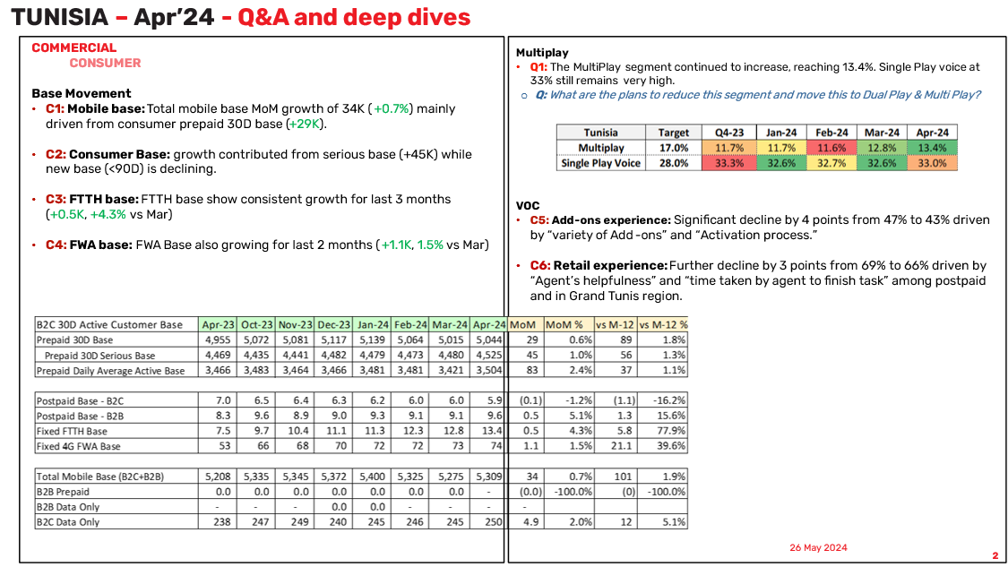  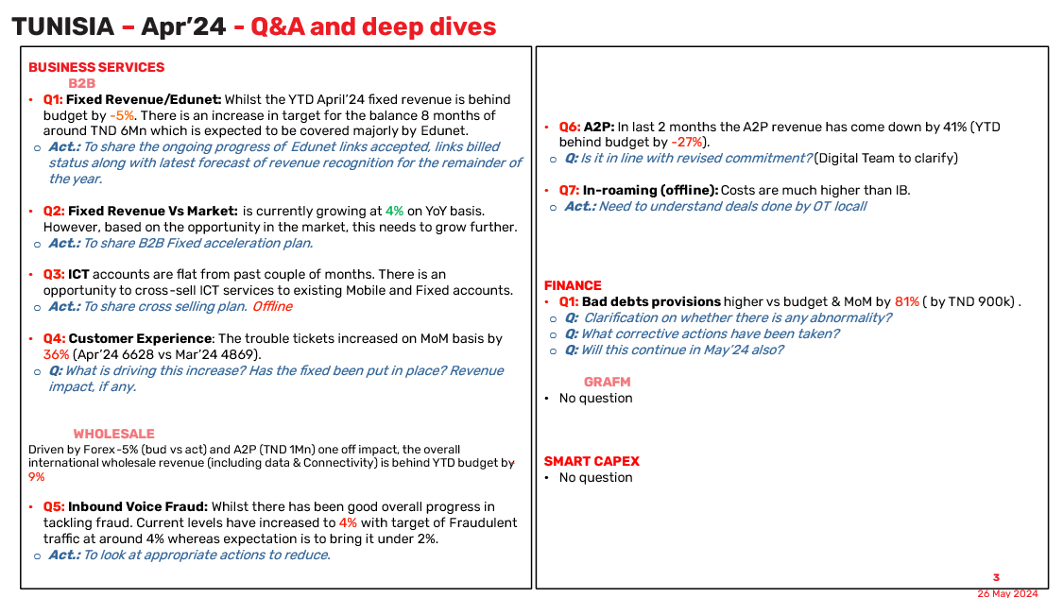  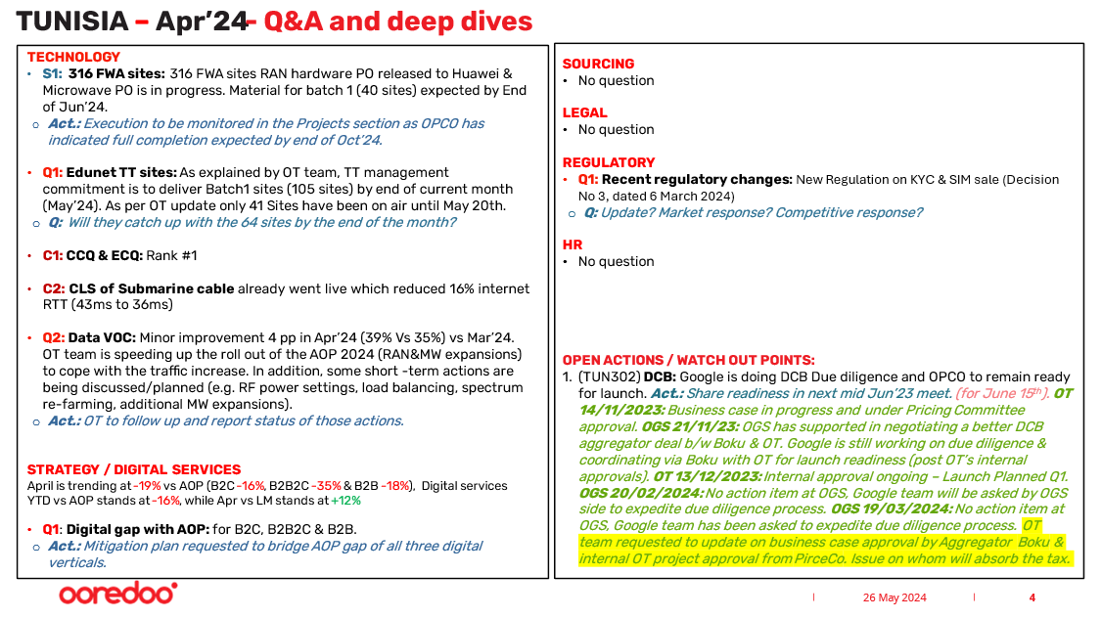  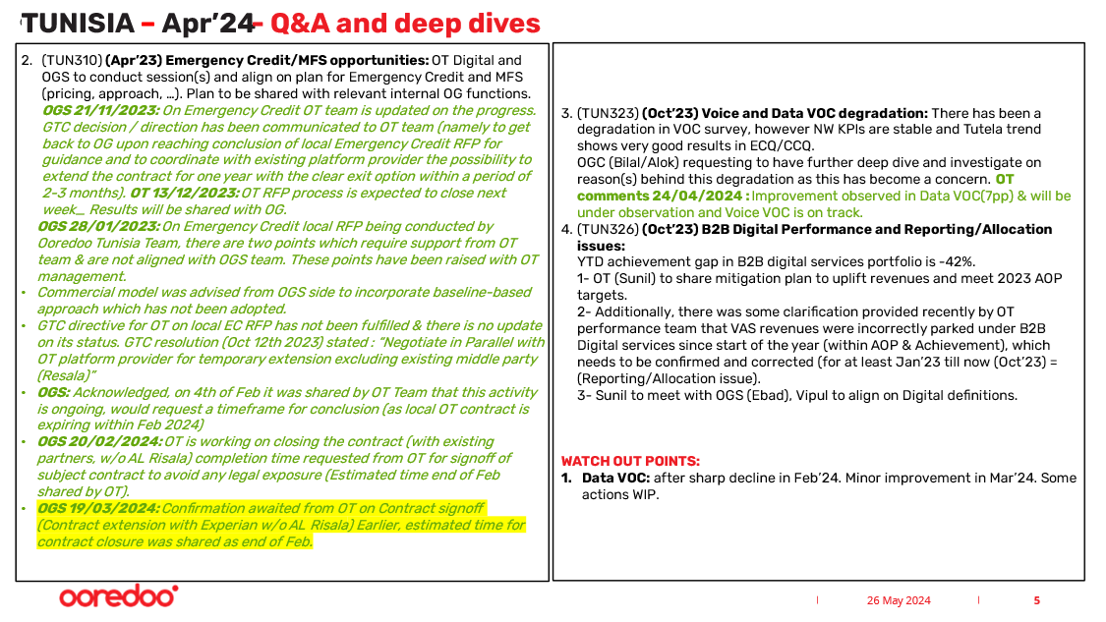  COMMERCIAL  GCCO Bilal informed that Cross OpCo visit of OA S&D team visiting OT has brought much learnings.  Well done on the 30Days serious base increase while GA are going down.  With the positive impact on the service revenue Vs target and YoY, one can only further emphasize the need to reenforce the growth of the serious base.  OGC/Alok suggested to use Myanmar experience (Joydeep, Sunil, Htar, …) in tackling the challenge on SIM registration. Alok will organize a shared session. NEW ACTION  CONSUMER  Base Movement  - C1: Mobile base: Total mobile base MoM growth of 34K (+0.7%) mainly driven from consumer prepaid 30D base (+29K).  - C2: Consumer Base: growth contributed from serious base (+45K) while new base (<90D) is declining.  - C3: FTTH base: FTTH base show consistent growth for last 3 months (+0.5K, +4.3% vs Mar)  - C4: FWA base: FWA Base also growing for last 2 months (+1.1K, 1.5% vs Mar)  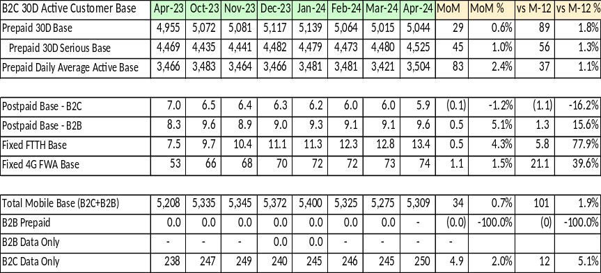  Multiplay  - Q1: The MultiPlay segment continued to increase, reaching 13.4%. Single Play voice at 33% still remains very high.  - Q: What are the plans to reduce this segment and move this to Dual Play & Multi Play?  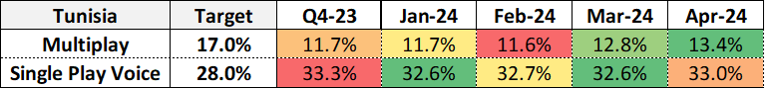  OT: “The increase is mainly the result of an upgrade of 200K from No play and 60K GA and reactivations during Aid. However, as a result of the CVM dedicated actions, we registered a decrease of the downgrades from higher segments in April compared to March by 25K. Also, the stable base decreased by 11K. “  VOC  - C5: Add-ons experience: Significant decline by 4 points from 47% to 43% driven by “variety of Add-ons” and “Activation process.”  OT: “Main actions that were already initiated to improve CSAT related to Variety of Add-ons :  - Launch of new data bundles to make alignment with competition such as the FB bundle of 30 days (1.125 Gb)  - Launch of innovative add-ons bundled with Shaihd service « Exclusivity on the market »  Improving CX of data bundles:  - A detailed roadmap of initiatives was already settled  - Feedback form VOC & several usability tests were initiated to identify pain points”  - C6: Retail experience: Further decline by 3 points from 69% to 66% driven by “Agent’s helpfulness” and “time taken by agent to finish task” among postpaid and in Grand Tunis region.  OT: “A slight decline was observed from March to April but the target of 67% was already reached and we are still performing better that last year. Nevertheless, a defined roadmap was settled to improve the score.”  B2B  GCBSO/Najib commented on the good work in executing the existing plan.  Fixed and ICT need to grow.  Group has a good relationship with hyper-scalers and there is a huge opportunity for OT to become the hub in the region. The strategy moving forward is to bring these hyper-scalers into Tunisia.  - Q1: Fixed Revenue/Edunet: Whilst the YTD April’24 fixed revenue is behind budget by -5%. There is an increase in target for the balance 8 months of around TND 6Mn which is expected to be covered majorly by Edunet.  - Act.: To share the ongoing progress of Edunet links accepted, links billed status along with latest forecast of revenue recognition for the remainder of the year.  OT: “We invoiced 130 sites one off in November last year we will invoice additional 140 sites in June that will bring above 4M TND one off”.  - Q2: Fixed Revenue Vs Market: is currently growing at 4% on YoY basis. However, based on the opportunity in the market, this needs to grow further.  - Act.: To share B2B Fixed acceleration plan.  OT: “Several actions plan are on going: Uplift with new products, WIFI managed services (1st hotel signed), SDWAN a service (June) to attack completion MPLS clients, commission revamp (done),”  - Q3: ICT accounts are flat from past couple of months. There is an opportunity to cross-sell ICT services to existing Mobile and Fixed accounts.  - Act.: To share cross selling plan. Offline  - Q4: Customer Experience: The trouble tickets increased on MoM basis by 36% (Apr’24 6628 vs Mar’24 4869).  - Q: What is driving this increase? Has the fixed been put in place? Revenue impact, if any.  OT: “No revenue impact, fixed impleted when it’s the case”  WHOLESALEesal  Driven by Forex -5% (bud vs act) and A2P (TND 1Mn) one off impact, the overall international wholesale revenue (including data & Connectivity) is behind YTD budget by -9%  - Q5: Inbound Voice Fraud: Whilst there has been good overall progress in tackling fraud. Current levels have increased to 4% with target of Fraudulent traffic at around 4% whereas expectation is to bring it under 2%.  - Act.: To look at appropriate actions to reduce.  OT: “Inbound fraud is mainly offnet & depends on the numbers of Tunisie Telecom used sim’s by the fraudster.  No action can be done at OT level”.  - Q6: A2P: In last 2 months the A2P revenue has come down by 41% (YTD behind budget by -27%).  - Q: Is it in line with revised commitment? (Digital Team to clarify)  OT: “Renegotiated commitment impact”  - Q7: In-roaming (offline): Costs are much higher than IB.  - Act.: Need to understand deals done by OT local  OT: “Details of all the deal shared with OG roaming team”  FINANCE  - Q1: Bad debts provisions higher vs budget & MoM by 81% ( by TND 900k) .  - Q: Clarification on whether there is any abnormality?  - Q: What corrective actions have been taken?  - Q: Will this continue in May’24 also?  OT: “Bad debt higher MoM driven by increase on suspended customers. Organic trend will be back in may”.  OT CFO/Philippe explained that there were some 20k 4G boxes that got suspended.  - Once subs goes from active to suspended then it triggers to bad debt provision.  - The automatic dunning system was not recognized in March.  - Apr’24 had 2 months of bad debt recognized.  - 60% of the 20k will go back as per normal dunning cycle.  GRAFM  - No question  SMART CAPEX  - No question  TECHNOLOGY  OT planning some upgrades. Alignment will be done before being officially announced.  - S1: 316 FWA sites: 316 FWA sites RAN hardware PO released to Huawei & Microwave PO is in progress. Material for batch 1 (40 sites) expected by End of Jun’24.  - Act.: Execution to be monitored in the Projects section as OPCO has indicated full completion expected by end of Oct’24.  OT: “aligned”  - Q1: Edunet TT sites: As explained by OT team, TT management commitment is to deliver Batch1 sites (105 sites) by end of current month (May’24). As per OT update only 41 Sites have been on air until May 20th.  - Q: Will they catch up with the 64 sites by the end of the month?  OT: “A close follow-up is held on weekly basis with TT management, Things start to move forward, We are confident to secure 50 sites by end of May, the 55 remaining sites (Batch 1) to be secured in June”.  - C1: CCQ & ECQ: Rank #1  - C2: CLS of Submarine cable already went live which reduced 16% internet RTT (43ms to 36ms)  - Q2: Data VOC: Minor improvement 4 pp in Apr’24 (39% Vs 35%) vs Mar’24. OT team is speeding up the roll out of the AOP 2024 (RAN&MW expansions) to cope with the traffic increase. In addition, some short-term actions are being discussed/planned (e.g. RF power settings, load balancing, spectrum re-farming, additional MW expansions).  - Act.: OT to follow up and report status of those actions.  OT: “OT Technology already aligned with OG technology, an action plan is being finalized, once ready it will be shared with OG”  STRATEGY / DIGITAL SERVICES  April is trending at -19% vs AOP (B2C -16%, B2B2C -35% & B2B -18%), Digital services YTD vs AOP stands at -16%, while Apr vs LM stands at +12%  - Q1: Digital gap with AOP: for B2C, B2B2C & B2B.  - Act.: Mitigation plan requested to bridge AOP gap of all three digital verticals.  GCSO/Rene commented on the great performance overall.  We are still to see some growth in Digital. This segment needs to be back to growth  Need a mini workshop with digital team to see what could be accelerated and used from current portfolio to close the gap. To set up this workshop in next 1-2 weeks. NEW ACTION  OT CFO/Philippe informing that some VAS initiatives will be launched in B2B which will bridge some of the gap.  SOURCING  - No question  LEGAL  - No question  REGULATORY  - Q1: Recent regulatory changes: New Regulation on KYC & SIM sale (Decision No 3, dated 6 March 2024)  - Q: Update? Market response? Competitive response?  OT: “Regulatory: The decision is actually driven by security authorities to mitigate risks triggered by the usage of dummy SIMs or with fake IDs, which is a real phenomenon.  All 3 MNOs are obliged to comply, with certain timelines, as the Decision introduces a set of measures, not all to apply from day 1.  As of today, all of 3 MNOs implemented most of the requirements, but none of the 3 is fully compliant.  OT Marketing/Sales: Welcome bonus : effective from Ooredoo side starting May 7th , we raised complaint to regulator for competition to stop.  Regarding the other rules still under evaluation and impact assessment”.  HR  - No question  OPEN ACTIONS / WATCH OUT POINTS:  - (TUN302) DCB: Google is doing DCB Due diligence and OPCO to remain ready for launch. Act.: Share readiness in next mid Jun’23 meet. (for June 15th). OT 14/11/2023: Business case in progress and under Pricing Committee approval. OGS 21/11/23: OGS has supported in negotiating a better DCB aggregator deal b/w Boku & OT. Google is still working on due diligence & coordinating via Boku with OT for launch readiness (post OT’s internal approvals). OT 13/12/2023: Internal approval ongoing – Launch Planned Q1. OGS 20/02/2024: No action item at OGS, Google team will be asked by OGS side to expedite due diligence process. OGS 19/03/2024: No action item at OGS, Google team has been asked to expedite due diligence process. OT team requested to update on business case approval by Aggregator Boku & internal OT project approval from PirceCo. Issue on whom will absorb the tax.  - (TUN310) (Apr’23) Emergency Credit/MFS opportunities: OT Digital and OGS to conduct session(s) and align on plan for Emergency Credit and MFS (pricing, approach, …). Plan to be shared with relevant internal OG functions. OGS 21/11/2023: On Emergency Credit OT team is updated on the progress. GTC decision / direction has been communicated to OT team (namely to get back to OG upon reaching conclusion of local Emergency Credit RFP for guidance and to coordinate with existing platform provider the possibility to extend the contract for one year with the clear exit option within a period of 2-3 months). OT 13/12/2023: OT RFP process is expected to close next week_ Results will be shared with OG.  OGS 28/01/2023: On Emergency Credit local RFP being conducted by Ooredoo Tunisia Team, there are two points which require support from OT team & are not aligned with OGS team. These points have been raised with OT management.  - Commercial model was advised from OGS side to incorporate baseline-based approach which has not been adopted.  - GTC directive for OT on local EC RFP has not been fulfilled & there is no update on its status. GTC resolution (Oct 12th 2023) stated : “Negotiate in Parallel with OT platform provider for temporary extension excluding existing middle party (Resala)”  - OGS: Acknowledged, on 4th of Feb it was shared by OT Team that this activity is ongoing, would request a timeframe for conclusion (as local OT contract is expiring within Feb 2024)  - OGS 20/02/2024: OT is working on closing the contract (with existing partners, w/o AL Risala) completion time requested from OT for signoff of subject contract to avoid any legal exposure (Estimated time end of Feb shared by OT).  - OGS 19/03/2024: Confirmation awaited from OT on Contract signoff (Contract extension with Experian w/o AL Risala) Earlier, estimated time for contract closure was shared as end of Feb.  - (TUN323) (Oct’23) Voice and Data VOC degradation: There has been a degradation in VOC survey, however NW KPIs are stable and Tutela trend shows very good results in ECQ/CCQ.  OGC (Bilal/Alok) requesting to have further deep dive and investigate on reason(s) behind this degradation as this has become a concern. OT comments 24/04/2024 : Improvement observed in Data VOC(7pp) & will be under observation and Voice VOC is on track.  - (TUN326) (Oct’23) B2B Digital Performance and Reporting/Allocation issues:  YTD achievement gap in B2B digital services portfolio is -42%.  1- OT (Sunil) to share mitigation plan to uplift revenues and meet 2023 AOP targets.  2- Additionally, there was some clarification provided recently by OT performance team that VAS revenues were incorrectly parked under B2B Digital services since start of the year (within AOP & Achievement), which needs to be confirmed and corrected (for at least Jan’23 till now (Oct’23) = (Reporting/Allocation issue).  3- Sunil to meet with OGS (Ebad), Vipul to align on Digital definitions.  WATCH OUT POINTS:  - Data VOC: after sharp decline in Feb’24. Minor improvement in Mar’24. Some actions WIP. | NEW ACTION  (Apr24) SIM Registration challenge (process to check the customers IDs): OGC/Alok to organize a shared session with ex Myanmar team (Htar, Vivek, Nitin) and OT Team (Sunil, Joy, Mathias) on SIM registration to capitalize on their experience in implementing best practice at OT.  (By mid Jun’24)  NEW ACTION  (Apr’24) Digital workshop to boost performance: OGS/Rene to organize a mini workshop to see what could be accelerated from current digital portfolio to close gap with targets.  (By end of Jun’24)
3. | Closing Words  GRCEO/Ahmad concluded session: nice to see the sustainable growth. OG is counting on OT team to see more growth.
4. | Open Actions – General reminder that open actions as shared by the OG Performance Team should be addressed and followed up by the dates requested.

